| Please choose a lesson, or type 0 to return to course menu.

1: Principles of Analytic Graphs 2: Exploratory Graphs 3: Graphics Devices in R

4: Plotting Systems 5: Base Plotting System 6: Lattice Plotting System

7: Working with Colors 8: GGPlot2 Part1 9: GGPlot2 Part2

10: GGPlot2 Extras 11: Hierarchical Clustering 12: K Means Clustering

13: Dimension Reduction 14: Clustering Example 15: CaseStudy

Selection: 14

| Attemping to load lesson dependencies...

| Package ‘fields’ loaded correctly!

| Package ‘jpeg’ loaded correctly!

| Package ‘datasets’ loaded correctly!

| | 0%

| Clustering_Example. (Slides for this and other Data Science courses may be found at github

| https://github.com/DataScienceSpecialization/courses/. If you care to use them, they must be downloaded as a zip file and

| viewed locally. This lesson corresponds to 04_ExploratoryAnalysis/clusteringExample.)

...

|== | 2%

| In this lesson we'll apply some of the analytic techniques we learned in this course to data from the University of

| California, Irvine. Specifically, the data we'll use is from UCI's Center for Machine Learning and Intelligent Systems. You

| can find out more about the data at http://archive.ics.uci.edu/ml/datasets/Human+Activity+Recognition+Using+Smartphones. As

| this address indicates, the data involves smartphones and recognizing human activity. Cool, right?

...

|==== | 3%

| Our goal is to show you how to use exploratory data analysis to point you in fruitful directions of research, that is,

| towards answerable questions. Exploratory data analysis is a "rough cut" or filter which helps you to find the most

| beneficial areas of questioning so you can set your priorities accordingly.

...

|===== | 5%

| We also hope to show you that "real-world" research isn't always neat and well-defined like textbook questions with

| clearcut answers.

...

|======= | 6%

| We've loaded data from this study for you in a matrix called ssd. Run the R command dim now to see its dimensions.

> dim(ssd)

[1] 7352 563

| Keep up the great work!

|========= | 8%

| Wow - ssd is pretty big, 7352 observations, each of 563 variables. Don't worry we'll only use a small portion of this

| "Human Activity Recognition database".

...

|=========== | 9%

| The study creating this database involved 30 volunteers "performing activities of daily living (ADL) while carrying a

| waist-mounted smartphone with embedded inertial sensors. ... Each person performed six activities ... wearing a smartphone

| (Samsung Galaxy S II) on the waist. ... The experiments have been video-recorded to label the data manually. The obtained

| dataset has been randomly partitioned into two sets, where 70% of the volunteers was selected for generating the training

| data and 30% the test data."

...

|============= | 11%

| Use the R command names with just the last two columns (562 and 563) of ssd to see what data they contain.

> names(ssd[562:563])

[1] "subject" "activity"

| Your dedication is inspiring!

|============== | 12%

| These last 2 columns contain subject and activity information. We saw above that the gathered data had "been randomly

| partitioned into two sets, where 70% of the volunteers was selected for generating the training data and 30% the test

| data." Run the R command table with ssd$subject as its argument to see if the data in ssd contains training or test data.

> table(ssd$subject)

1 3 5 6 7 8 11 14 15 16 17 19 21 22 23 25 26 27 28 29 30

347 341 302 325 308 281 316 323 328 366 368 360 408 321 372 409 392 376 382 344 383

| You got it right!

|================ | 14%

| From the number of subjects, would you infer that ssd contains training or test data?

1: training

2: test

Selection: 1

| Great job!

|================== | 16%

| So ssd contains only training data. If you ran the R command sum with table(ssd$subject) as its argument, what would the

| number you get back represent?

1: the number of rows and columns of ssd

2: the number of columns in ssd

3: the number of rows in ssd

4: Huh?

Selection: 3

| You're the best!

|==================== | 17%

| Try it now (running sum on table(ssd$subject))to see if you get 7352, the number of rows in ssd, as a result.

> sum(table(ssd$subject))

[1] 7352

| All that practice is paying off!

|====================== | 19%

| So we're looking at training data from a machine learning repository. We can infer that this data is supposed to train

| machines to recognize activity collected from the accelerometers and gyroscopes built into the smartphones that the

| subjects had strapped to their waists. Run the R command table on ssd$activity to see what activities have been

| characterized by this data.

> table(ssd$activity)

laying sitting standing walk walkdown walkup

1407 1286 1374 1226 986 1073

| You're the best!

|======================== | 20%

| We have 6 activities, 3 passive (laying, standing and sitting) and 3 active which involve walking. If you ran the R command

| sum with table(ssd$activity) as its argument, what would the number you get back represent?

1: the number of columns in ssd

2: the number of rows in ssd

3: the number of rows and columns of ssd

4: Huh?

Selection: 2

| You're the best!

|========================= | 22%

| Because it's training data, each row is labeled with the correct activity (from the 6 possible) and associated with the

| column measurements (from the accelerometer and gyroscope). We're interested in questions such as, "Is the correlation

| between the measurements and activities good enough to train a machine?" so that "Given a set of 561 measurements, would a

| trained machine be able to determine which of the 6 activities the person was doing?"

...

|=========================== | 23%

| First, let's massage the data a little so it's easier to work with. We've already run the R command transform on the data

| so that activities are factors. This will let us color code them when we generate plots. Let's look at only the first

| subject (numbered 1). Create the variable sub1 by assigning to it the output of the R command subset with ssd as the first

| argument and the boolean, subject equal to 1, as the second.

> sub1 <- subset(ssd, subject == 1)

| You got it!

|============================= | 25%

| Look at the dimensions of sub1 now.

> dim(sub1)

[1] 347 563

| All that hard work is paying off!

|=============================== | 27%

| So sub1 has fewer than 400 rows now, but still a lot of columns which contain measurements. Use names on the first 12

| columns of sub1 to see what kind of data we have.

> names(sub1[1:12])

[1] "tBodyAcc.mean...X" "tBodyAcc.mean...Y" "tBodyAcc.mean...Z" "tBodyAcc.std...X" "tBodyAcc.std...Y" "tBodyAcc.std...Z"

[7] "tBodyAcc.mad...X" "tBodyAcc.mad...Y" "tBodyAcc.mad...Z" "tBodyAcc.max...X" "tBodyAcc.max...Y" "tBodyAcc.max...Z"

| You are quite good my friend!

|================================= | 28%

| We see X, Y, and Z (3 dimensions) of different aspects of body acceleration measurements, such as mean and standard

| deviation. Let's do some comparisons of activities now by looking at plots of mean body acceleration in the X and Y

| directions. Call the function myedit with the string "showXY.R" to see the code generating the plots. Make sure your cursor

| is back in the console window before you hit any more buttons.

> myedit("showXY.R")

| That's a job well done!

|================================== | 30%

showXY.R

par(mfrow=c(1, 2), mar = c(5, 4, 1, 1))

plot(sub1[, 1], col = sub1$activity, ylab = names(sub1)[1])

plot(sub1[, 2], col = sub1$activity, ylab = names(sub1)[2])

legend("bottomright",legend=unique(sub1$activity),col=unique(sub1$activity), pch = 1)

par(mfrow=c(1,1))

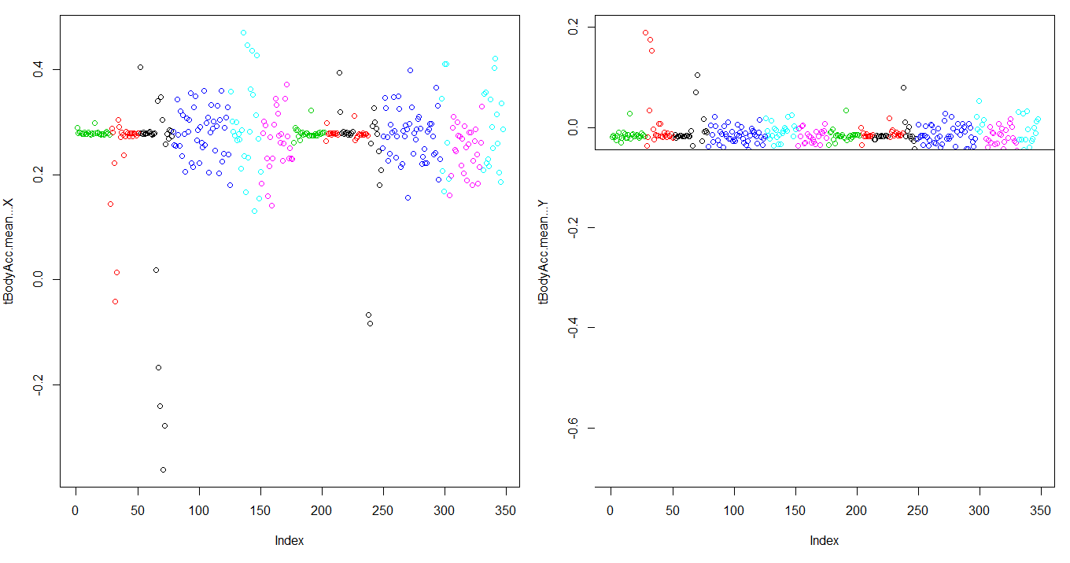

| You see both the code and its output! The plots are a little squished, but we see that the active activities related to

| walking (shown in the two blues and magenta) show more variability than the passive activities (shown in black, red, and

| green), particularly in the X dimension.

...

|==================================== | 31%

| The colors are a little hard to distinguish. Just for fun, call the function showMe (we used it in the Working_with_Colors

| lesson) which displays color vectors. Use the vector 1:6 as its argument, and hopefully this will clarify the colors you

| see in the XY comparison plot.

> showMe(c(1:6))

| All that practice is paying off!

|====================================== | 33%

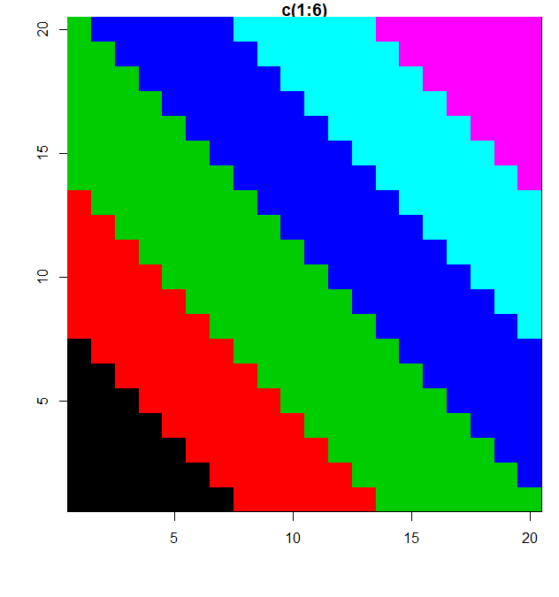

| Nice! We just wanted to show you the beauty and difference in colors. The colors at the bottom, black, red and green, mark

| the passive activities, while the true blues and magenta near the top show the walking activities. Let's try clustering to

| see if we can distinguish the activities more.

...

|======================================== | 34%

| We'll still focus on the 3 dimensions of mean acceleration. (The plot we just saw looked at the first 2 dimensions.) Create

| a distance matrix, mdist, of the first 3 columns of sub1, by using the R command dist. Use the x[,1:3] notation to specify

| the columns.

> mdist <- dist(sub1[, 1:3])

| You got it!

|========================================== | 36%

| Now create the variable hclustering by calling the R command hclust and passing it mdist as an argument. This will use the

| Euclidean distance as its default metric.

> hclustering <- hclust(mdist)

| Perseverance, that's the answer.

|============================================ | 38%

| Now call the pretty plotting function (which we've already sourced) myplclust with 2 arguments. The first is hclustering,

| and the second is the argument lab.col set equal to unclass(sub1$activity).

> myplclust(hclustering, lab.col = unclass(sub1$activity))

| You nailed it! Good job!

|============================================= | 39%

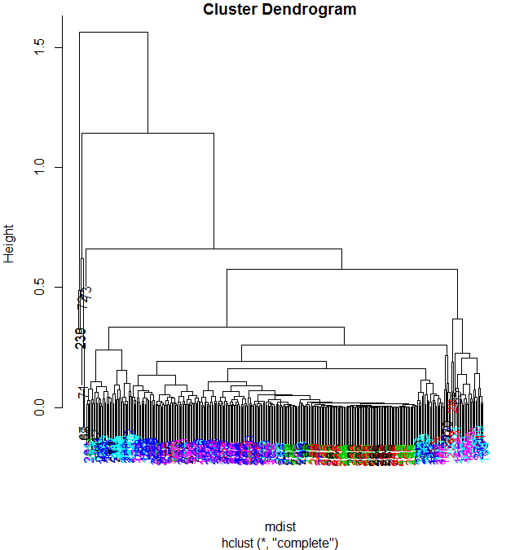

| Well that dendrogram doesn't look too helpful, does it? There's no clear grouping of colors, except that active colors

| (blues and magenta) are near each other as are the passive (black, red, and green). So average acceleration doesn't tell us

| much. How about maximum acceleration? Let's look at that for the first subject (in our array sub1) for the X and Y

| dimensions. These are in column 10 and 11.

...

|=============================================== | 41%

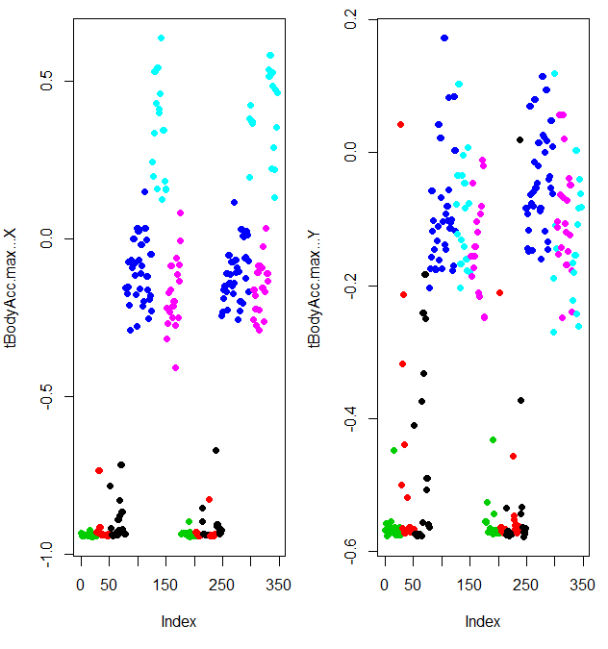

| Here they are plotted side by side, X dimension on the left and Y on the right. The x-axis of each show the 300+

| observations and the y-axis indicates the maximum acceleration.

...

|================================================= | 42%

| From the 2 plots, what separation, if any, do you see?

1: laying generates the most acceleration in the X dimension

2: there is no pattern

3: passive activities mostly fall below the walking activities

4: passive activities generate the most acceleration

Selection: 3

| All that hard work is paying off!

|=================================================== | 44%

| Finally we're seeing something vaguely interesting! Let's focus then on the 3 dimensions of maximum acceleration, stored in

| columns 10 through 12 of sub1. Create a new distance matrix, mdist, of these 3 columns of sub1, by using the R command

| dist. Again, use the x[,10:12] notation to catch the columns.

> mdist <- dist(sub1[, 10:12])

| You nailed it! Good job!

|===================================================== | 45%

| Now create the variable hclustering by calling hclust with mdist as the argument.

> hclustering <- hclust(mdist)

| That's the answer I was looking for.

|====================================================== | 47%

| Again, call the myplclust with 2 arguments. The first is hclustering, and the second is the argument lab.col set equal to

| unclass(sub1$activity).

> myplclust(hclustering, lab.col = unclass(sub1$activity))

| Excellent job!

|======================================================== | 48%

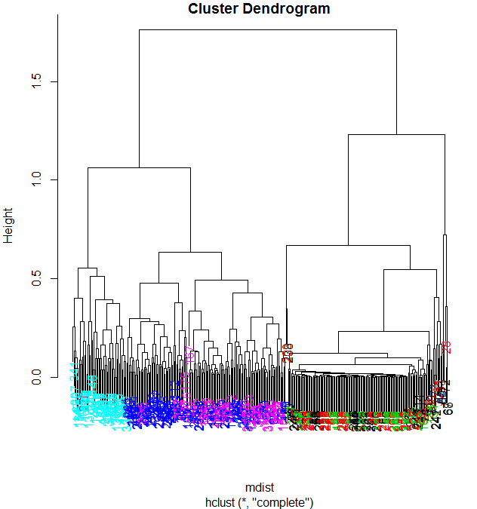

| Now we see clearly that the data splits into 2 clusters, active and passive activities. Moreover, the light blue (walking

| down) is clearly distinct from the other walking activities. The dark blue (walking level) also seems to be somewhat

| clustered. The passive activities, however, seem all jumbled together with no clear pattern visible.

...

|========================================================== | 50%

| Let's try some SVD now. Create the variable svd1 by assigning to it the output of a call to the R command svd. The argument

| to svd should be scale(sub1[,-c(562,563)]). This will remove the last 2 columns from sub1 and scale the data. Recall that

| the last 2 columns contain activity and subject information which we won't need.

> svd1 <- svd(scale(sub1[, -c(562, 563)]))

| You are quite good my friend!

|============================================================ | 52%

| To see LEFT singular vectors of sub1, which component of svd1 would we examine?

1: d

2: u

3: v

4: x

Selection: 2

| Great job!

|============================================================== | 53%

| Call the R command dim with svd1$u as an argument.

> dim(svd1$u)

[1] 347 347

| That's correct!

|=============================================================== | 55%

| We see that the u matrix is a 347 by 347 matrix. Each row in u corresponds to a row in the matrix sub1. Recall that in sub1

| each row has an associated activity.

...

|================================================================= | 56%

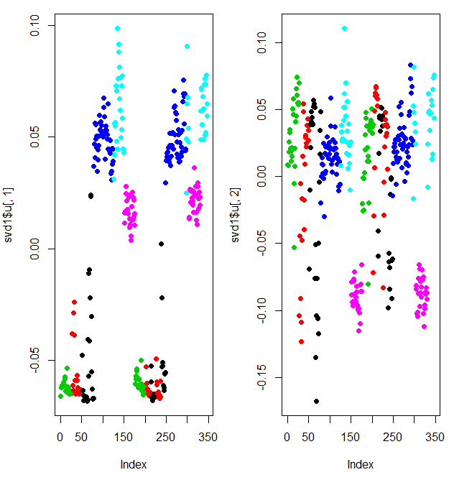

| Here we're looking at the 2 left singular vectors of svd1 (the first 2 columns of svd1$u). Each entry of the columns

| belongs to a particular row with one of the 6 activities assigned to it. We see the activities distinguished by color.

| Moving from left to right, the first section of rows are green (standing), the second red (sitting), the third black

| (laying), etc. The first column of u shows separation of the nonmoving (black, red, and green) from the walking

| activities. The second column is harder to interpret. However, the magenta cluster, which represents walking up, seems

| separate from the others.

...

|=================================================================== | 58%

| We'll try to figure out why that is. To do that we'll have to find which of the 500+ measurements (represented by the

| columns of sub1) contributes to the variation of that component. Since we're interested in sub1 columns, we'll look at the

| RIGHT singular vectors (the columns of svd1$v), and in particular, the second one since the separation of the magenta

| cluster stood out in the second column of svd1$u.

...

|===================================================================== | 59%

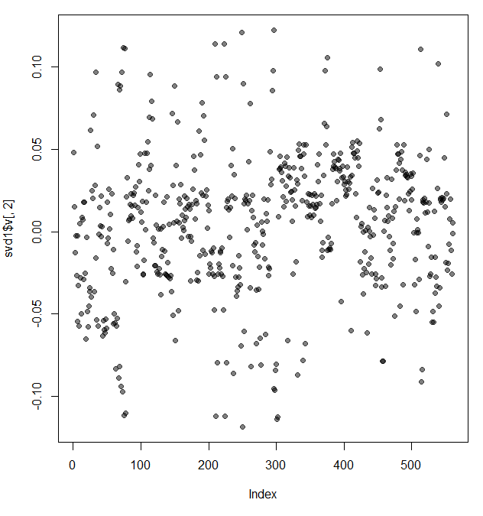

| Here's a plot of the second column of svd1$v. We used transparency in our plotting but nothing clearly stands out here.

| Let's use clustering to find the feature (out of the 500+) which contributes the most to the variation of this second

| column of svd1$v.

...

|======================================================================= | 61%

| Create the variable maxCon by assigning to it the output of the R command which.max using the second column of svd1$v as an

| argument.

> maxCon <- which.max(svd1$v[,2])

| You nailed it! Good job!

|======================================================================== | 62%



| Now create a distance matrix mdist by assigning to it the output of the R command dist using 4 columns of sub1 as the

| arguments. These 4 columns are 10 through 12 (10:12) and maxCon. Recall that you'll have to concatenate these 2 column

| expressions when specifying them.

> mdist <- dist(sub1[, 10:12], maxCon)

Error in dist(sub1[, 10:12], maxCon) : invalid distance method

> mdist <- dist(sub1[, 10:12 + maxCon])

| You're close...I can feel it! Try it again. Or, type info() for more options.

| Type mdist <- dist(sub1[,c(10:12,maxCon)]) at the command prompt.

> mdist <- dist(sub1[,c(10:12,maxCon)])

| Nice work!

|========================================================================== | 64%

| Now create hclustering, the output of the R command hclust using mdist as the argument.

> hclustering <- hclust(mdist)

| You're the best!

|============================================================================ | 66%

| Call the myplclust with 2 arguments, hclustering, and lab.col set equal to unclass(sub1$activity).

> myplclust(hclustering, lab.col = unclass(sub1$activity))

| You are really on a roll!

|============================================================================== | 67%

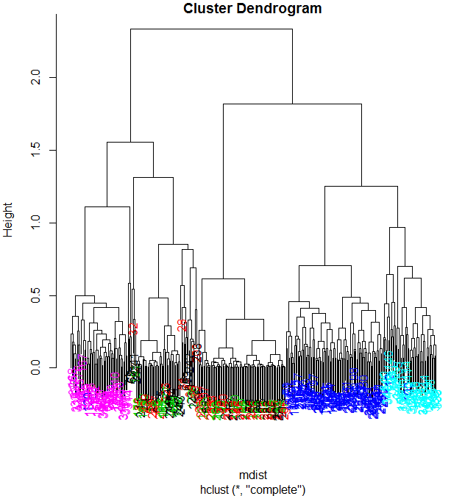

| Now we see some real separation. Magenta (walking up) is on the far left, and the two other walking activities, the two

| blues, are on the far right, but in separate clusters from one another. The nonmoving activities still are jumbled

| together.

...

|================================================================================ | 69%

| Run the R command names with the argument sub1[maxCon] to see what measurement is associated with this maximum contributor.

> names(sub1[maxCon])

[1] "fBodyAcc.meanFreq...Z"

| Great job!

|================================================================================== | 70%

| So the mean body acceleration in the frequency domain in the Z direction is the main contributor to this clustering

| phenomenon we're seeing. Let's move on to k-means clustering to see if this technique can distinguish between the

| activities.

...

|=================================================================================== | 72%

| Create the variable kClust by assigning to it the output of the R command kmeans with 2 arguments. The first is sub1 with

| the last 2 columns removed. (Recall these don't have pertinent information for clustering analysis.) The second argument to

| kmeans is centers set equal to 6, the number of activities we know we have.

> kClust <- kmeans(sub1[, -c(562:563)], centers = 6)

| You're the best!

|===================================================================================== | 73%

| Recall that without specifying coordinates for the cluster centroids (as we did), kmeans will generate starting points

| randomly. Here we did only 1 random start (the default). To see the output, run the R command table with 2 arguments. The

| first is kClust$cluster (part of the output from kmeans), and the second is sub1$activity.

> table(kClust$cluster, sub1$activity)

laying sitting standing walk walkdown walkup

1 17 12 6 0 0 0

2 9 2 0 0 0 0

3 0 0 0 0 0 53

4 0 0 0 95 0 0

5 24 33 47 0 0 0

6 0 0 0 0 49 0

| Great job!

|======================================================================================= | 75%

| Your exact output will depend on the state of your random number generator. We notice that when we just run with 1 random

| start, the clusters tend to group the nonmoving activities together in one cluster. The walking activities seem to cluster

| individually by themselves. You could run the call to kmeans with one random start again and you'll probably get a slightly

| different result, but....

...

|========================================================================================= | 77%

| ... instead call kmeans with 3 arguments, the last of which will tell it to try more random starts and return the best one.

| The first 2 arguments should be the same as before (sub1 with the last 2 columns removed and centers set equal to 6). The

| third is nstart set equal to 100. Put the result in kClust again.

> kClust <- kmeans(sub1[, -c(562:563)], centers = 6, nstart = 100)

| Nice work!

|=========================================================================================== | 78%

| Again, run the R command table with 2 arguments. The first is kClust$cluster (part of the output from kmeans), and the

| second is sub1$activity.

> table(kClust$cluster, sub1$activity)

laying sitting standing walk walkdown walkup

1 0 0 0 95 0 0

2 18 10 2 0 0 0

3 3 0 0 0 0 53

4 0 37 51 0 0 0

5 0 0 0 0 49 0

6 29 0 0 0 0 0

| Your dedication is inspiring!

|============================================================================================ | 80%

| We see that even with 100 random starts, the passive activities tend to cluster together. One of the clusters contains only

| laying, but in another cluster, standing and sitting group together.

...

|============================================================================================== | 81%

| Use dim to find the dimensions of kClust's centers. Use the x$y notation to access them.

> dim(kClust$centers)

[1] 6 561

| Nice work!

|================================================================================================ | 83%

| So the centers are a 6 by 561 array. Sometimes it's a good idea to look at the features (columns) of these centers to see

| if any dominate.

...

|================================================================================================== | 84%

| Create the variable laying and assign to it the output of the call to the R command which with the argument

| kClust$size==29.

> laying <- which(kClust$size==29)

| You got it right!

|==================================================================================================== | 86%

| Now call plot with 3 arguments. The first is kClust$centers[laying,1:12], and the second is pch set to 19. The third is

| ylab set equal to "Laying Cluster"

> plot(kClust$centers[laying, 1:12], pch = 19, ylab = "Laying Cluster")

| You are quite good my friend!

|====================================================================================================== | 88%

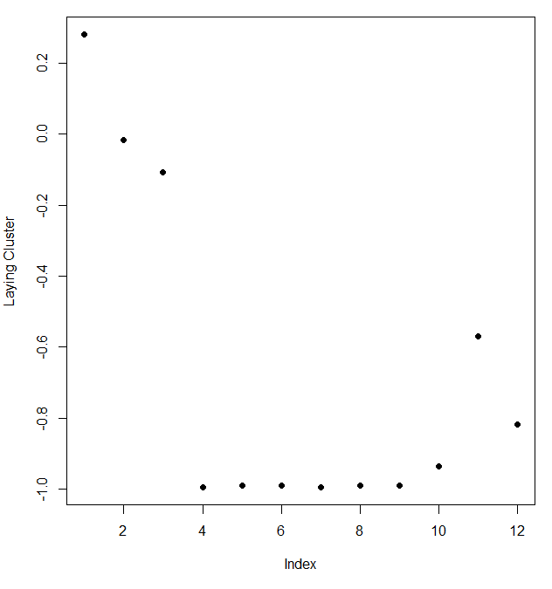

| We see the first 3 columns dominate this cluster center. Run names with the first 3 columns of sub1 as the argument to

| remind yourself of what these columns contain.

> names(sub1[,1:3])

[1] "tBodyAcc.mean...X" "tBodyAcc.mean...Y" "tBodyAcc.mean...Z"

| Great job!

|======================================================================================================= | 89%

| So the 3 directions of mean body acceleration seem to have the biggest effect on laying.

...

|========================================================================================================= | 91%

| Create the variable walkdown and assign to it the output of the call to the R command which with the argument

| kClust$size==49.

> walkdown <- which(kClust$size==49)

| You got it right!

|=========================================================================================================== | 92%

| Now call plot with 3 arguments. The first is kClust$centers[walkdown,1:12], and the second is pch set to 19. The third is

| ylab set equal to "Walkdown Cluster"

> plot(kClust$centers[walkdown, 1:12], pch = 19, ylab = "Walkdown Cluster")

| Great job!

|============================================================================================================= | 94%

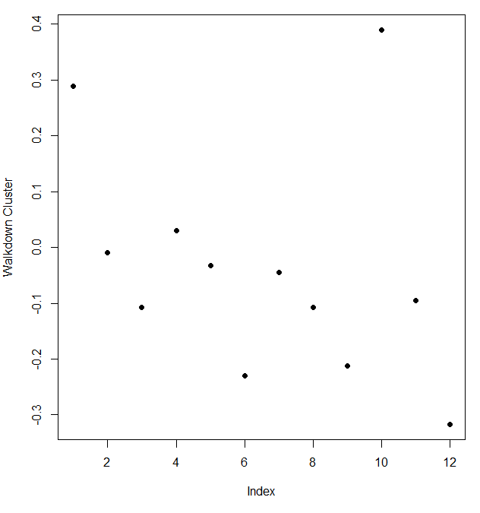

| We see an interesting pattern here. From left to right, looking at the 12 acceleration measurements in groups of 3, the

| points decrease in value. The X direction dominates, followed by Y then Z. This might tell us something more about the

| walking down activity.

...

|=============================================================================================================== | 95%

| We'll wrap up here and hope this example convinced you that real world analysis can be frustrating sometimes and not always

| obvious. You might have to try several techniques of exploratory data analysis before you hit one that pays off and leads

| you to the questioms that will be the most promising to explore.

...

|================================================================================================================ | 97%

| We saw here that the sensor measurements were pretty good at discriminating between the 3 walking activities, but the

| passive activities were harder to distinguish from one another. These might require more analysis or an entirely different

| set of sensory measurements.

...

|================================================================================================================== | 98%

| Congratulations! We hope you enjoyed the 6 activities and 500+ features of this lesson.

...

|====================================================================================================================| 100%